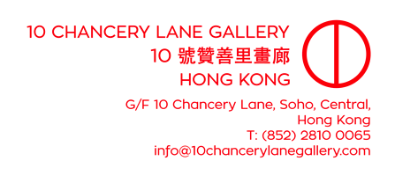
ATTN: ART EDITORS

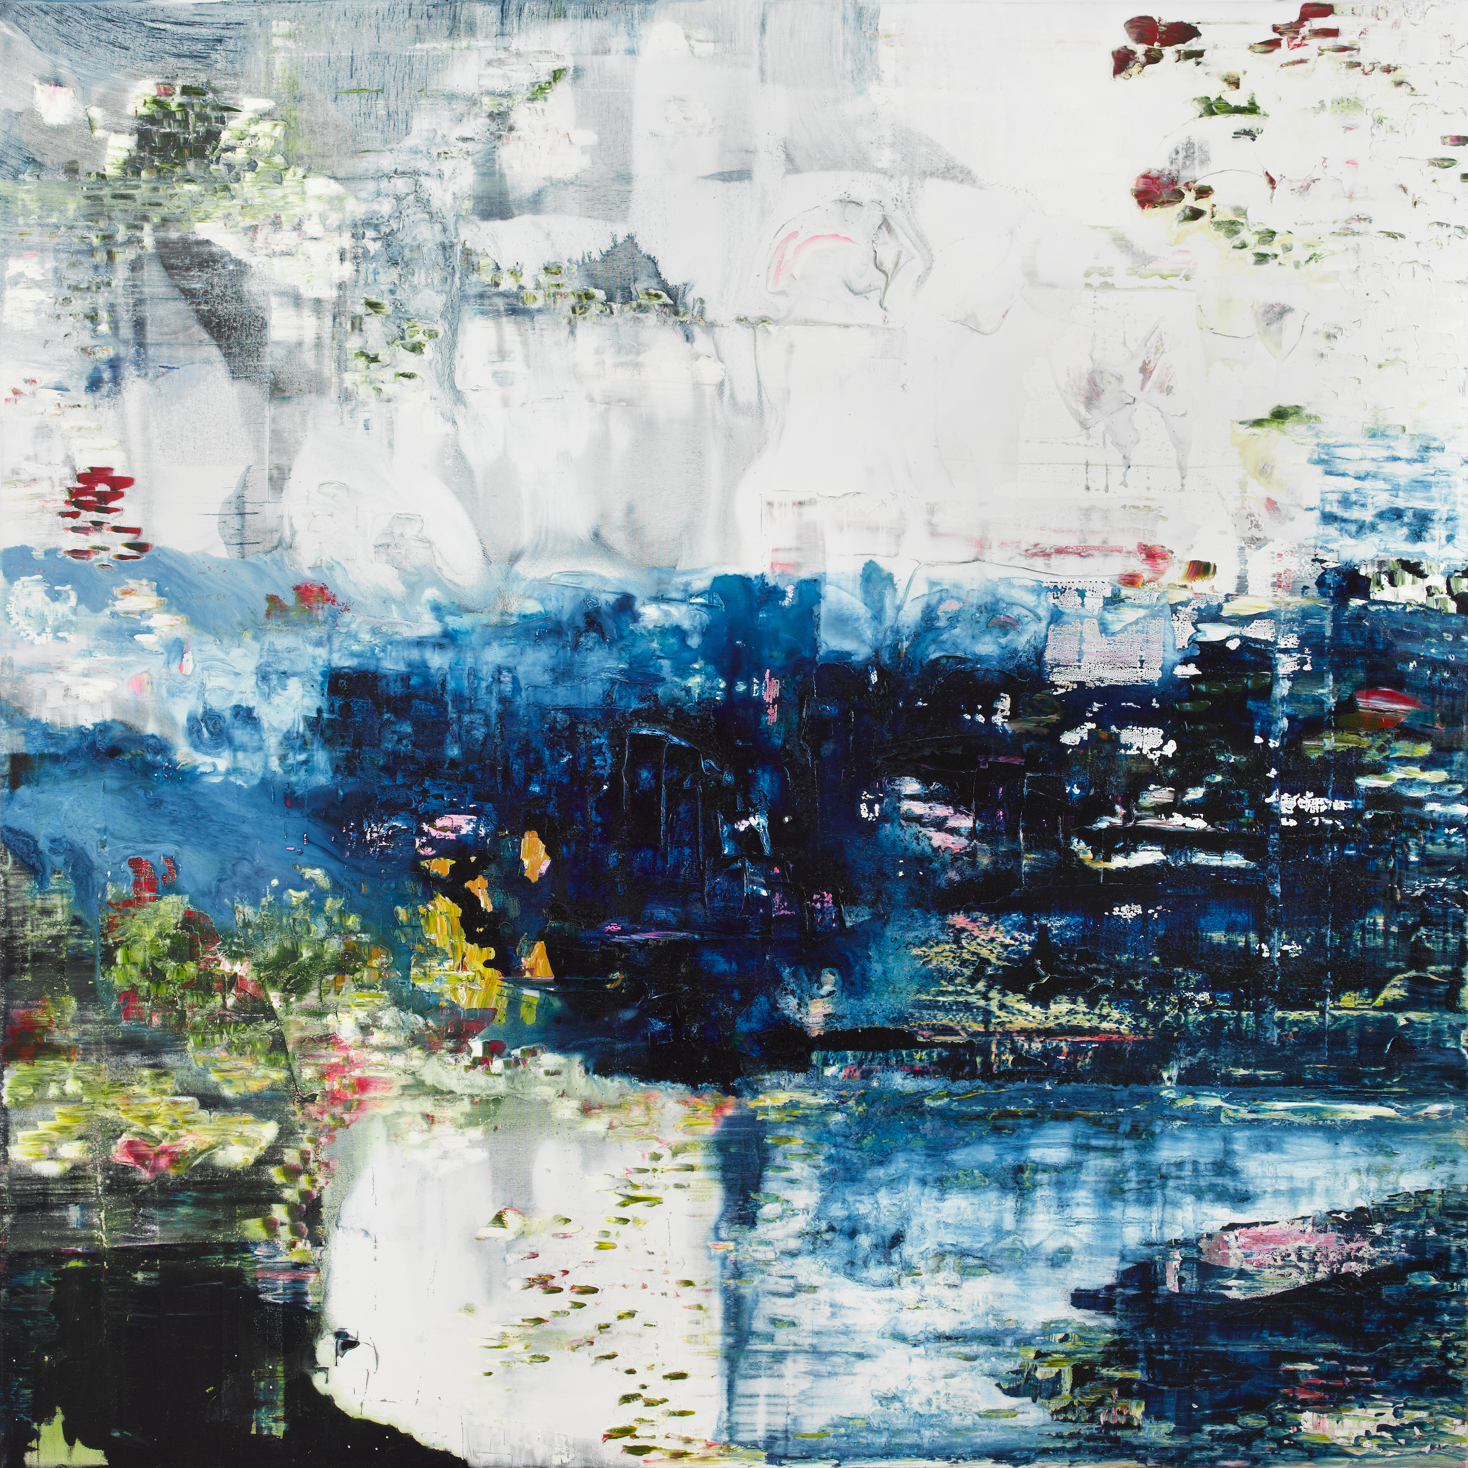
(Jessica Zoob, Midnight Garden 150 x 150 cm, Acrylic and Oil on Canvas)

10 CHANCERY LANE GALLERY PRESENTS BRITISH ARTIST
JESSICA ZOOB
A SERIES OF PAINTINGS AND EVENTS TO STIR OUR CONSCIOUSNESS TOWARDS THE BEAUTY AND FRAGILITY OF THE ENVIROMENT
“THIS MOMENT”

10 Chancery Lane Gallery is honoured to debut in Hong Kong British artist Jessica Zoob in her exhibition of paintings entitled “This Moment.” This body of work is about the extraordinary pivotal time we find ourselves in. The gallery will host a series of events to raise our consciousness towards the environment and use art as a way to do this.
In Jessica Zoob’s own words:
“This collection is about the precarious state of our planet, how passionate I am about it, how desperately I care for it, how fragile I understand it to be and how hopeful I am that with enough support and knowledge and people becoming less ignorant about what they are doing, by making good choices, by being willing to change and embrace the wild, we can actually protect and save our world and make it into the wonderful place it should be.
I hope to encourage people to stop and gaze, to be reminded of the beauty of nature and to be inspired to protect it.”
WORLD OCEANS DAY - 8 JUNE 2021, TUESDAY
With this inspiration in mind, 10 Chancery Lane Gallery along with Jessica Zoob is working for this exhibition to help the environment we live in. On June 8th 6-9pm we will host an evening for WORLD OCEANS DAY in collaboration with Craig Leeson and Julie Anderson of Plastic Oceans, Lea d’Auriol of Oceanic Global and Gary Stokes of Oceans Asia. Jessica has donated 2 paintings where 100% will go to these causes and all donations raised on the evening will go to Oceans Asia. Please rsvp@10chancerylanegallery.com to this event, subject World Oceans Day.
Later in the month we will be working to “Break the Chain - Stop Wildlife Traffickers Using our City”, an innovative city-wide mural campaign using Augmented Reality (AR) to bring to life paintings of animals trafficked through Hong Kong such as rhinos, pangolins, sharks. As well, we will be offering our support for Habitat for Humanity’s Hong Kong programs.
ABOUT JESSICA ZOOB
Jessica Zoob trained at Central School of Art and Nottingham University, during which time she travelled extensively. For seven years, she worked as a theatre designer at countless venues including the Bristol Old Vic, the Royal National Theatre and Greenwich Theatre. Since 2000, Jessica has worked exclusively as a British contemporary artist from her East Sussex studio. She exhibits regularly in and around London and has works in private collections worldwide. Collectors include Bernard Jacobson, Harry Styles, Juan Diego Florez, Francois Delage and Walter Dalkeith the Earl of Dalkeith. Jessica now resides In Hong Kong, is hugely inspired by Asia.
Jessica had a solo show in Cape Town with Southern Guild and has been the featured contemporary artist at London Design Week in Chelsea Harbour, London. She has had major solo collections shown at Loughran Gallery, Motcomb Street, Rove Gallery in Hoxton Square, The Great Room 1508 London, NEOBankside, South Bank and Medici Gallery, Cork Street. She has created a range of award winning textiles called Desire in collaboration with Romo.
“Zoob’s use of line, texture and colour recall the work of Gerhard Richter’s abstract paintings and the poetic quality of Claude Monet’s later works. However, they are rich in imagination with an innate energy and beauty all of their own.” – Leonie Irvine, Medici Gallery
ABOUT 10 CHANCERY LANE GALLERY
Celebrating 20 years in 2021, 10 Chancery Lane Gallery is one of Asia’s leading art galleries. With exhibitions that explore both emerging and historically important movements in art in the Asia-Pacific. The gallery continuously keeps its finger on the pulse of contemporary art from the region. 10 Chancery Lane Gallery aims to deliver exhibitions that take time, research and have an impact on the art in the region, as well as promoting contemporary art from Asia internationally.
Founder and Director Katie de Tilly arrived in Hong Kong in 1994 when Chinese and contemporary art from most of Asia was yet to come into international focus. With a particular interest in the deep historical, social and cultural context of Hong Kong and China and the development in Asia of its contemporary art scenes, she founded 10 Chancery Lane Gallery in 2001.10 Chancery Lane Gallery is dedicated to the development of young artists and organizes “HKForeword” since 2012 giving Hong Kong art graduates their first gallery exhibition. Katie de Tilly is the 2019 recipient of the “Woman of Influence in Arts and Culture” awarded by the American Chamber of Commerce. She was a founding member and former co-President of the Hong Kong Art Gallery Association (HKAGA), is on the Program Advisory Committee (PAC) of RMIT University School of Art /Hong Kong Art School. She is a Founding Patron of the West Kowloon Cultural District’s M+ Museum of Visual Culture. And she is heading the HK Artists Residency Abroad Funding Scheme (ARAFS) of the Hong Kong Art Gallery Association to help local artists enrich their art exposure and education. She was formerly a board member of the Tate Modern Asia Pacific Acquisitions Committee (Tate-APAC)

For Press Enquiries and to arrange interviews, please contact Ellen Zhuang
ellen@10chancerylanegallery.com or +852 2810 0065
High resolution image can be downloaded here:
https://www.dropbox.com/sh/quuiznbh6qzh7mk/AAC-Z5rOzDhFj14-ln0jBu1Na?dl=0
E-catalogue : JESSICA ZOOB THIS MOMENT
https://heyzine.com/flip-book/4e830c4d26.html

———————————————————————————————————————
“This Moment” by Jessica Zoob
10 Chancery Lane Gallery, Central, Hong Kong
Exhibition Period: 4 June – 15 August, 2021

Members of the Press are invited to meet Jessica Zoob on
World Oceans Day (Tuesday, 8 June 2021, 6-9pm)
at 10 Chancery Lane Gallery

