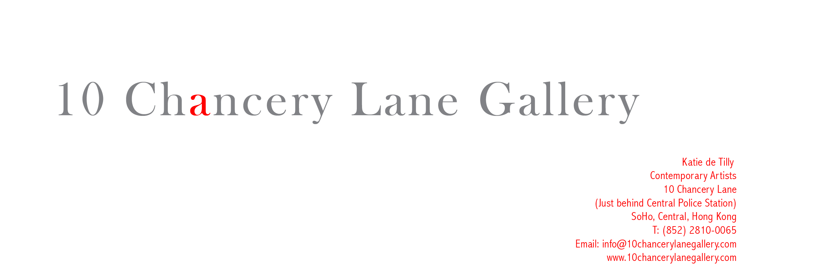

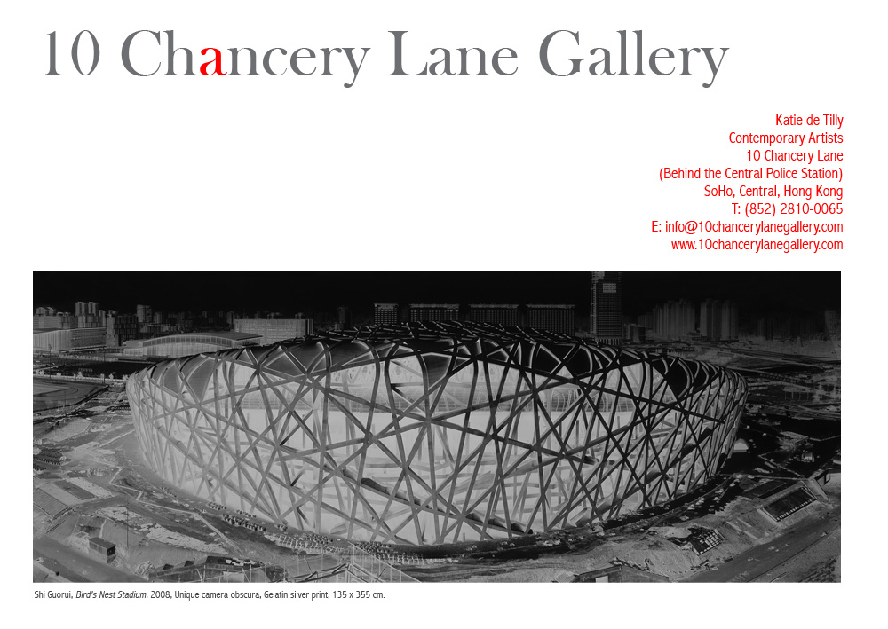

Press Release
Attn: Art Editors

CHINA’S MOST FAMOUS CAMERA OBSCURA PHOTOGRAPHER, SHI GUORUI, NEW WORKS AT 10 CHANCERY LANE GALLERY, HONG KONG

Hong Kong, June 5, 2008— 10 Chancery Lane Gallery is pleased to present the first solo exhibition of Shi Guorui in Hong Kong. Shi Guorui (b. 1964) is a Beijing-based artist who takes large-scale iconic photographs with a technique called camera obscura using a pinhole camera. He is called China’s most famous camera obscura photographer. His images of the Shanghai Skyline, Hong Kong Skyline and the famed Bird’s Nest Stadium designed by Ai Wei Wei will all be exhibited in this exhibition.

Shi Guorui’s interest in using the camera obscura method goes deeper than documenting monumental city scenes. In showing the cities, void of distraction, he steps into the realm of explaining or observing different cultures and social or political issues. Each city has its own culture and by searching through these photos there are unique philosophies observed. The black and white images reveal a great importance from the negative reversal and large scale of the photo that challenges the viewer to look deeper into familiar scenery. The process to him is very calming and purifying. The making of his photographs is as important as the photos themselves. He looks at it as a spiritual and meditative process and appreciates the way it allows him to escape the ever-fast-growing world around us, especially in China today.

The making of each image takes many hours and is very labor intensive. Several images are taken over several days. The photographs are monumental in size from 3 to 5 meters long for which he has to erect a giant blackened tent where he hangs the photographic paper and the image is exposed directly onto the paper using the tiny pinhole camera. Exposure times run from 90 minutes to 24 hours and he must stay in the tent during the process so no other light can seep in and destroy the image. The planning and preparation of each photo takes several months and many attempts must be made for each scene. His famed Mount Everest photo had to be taken over several trips and he lived in a tent on the snow-covered mountain top with a tank of oxygen near him at all times. He recalls the amount of difficulty he had to endure and remembers the experience as an enriching one bringing him one with nature.

Katie de Tilly cordially invites the press to the opening reception with the artist at 10 Chancery Lane Gallery Central that will be held on June 5, 2008 (Thur) from 6:30-8:30pm. The exhibition runs through the Olympics until August 30th, 2008.

For press enquiries or interviews please call Eliette Rosich on 9551-1240 or 2810-0161, or eliette@10chancerylanegallery.com

About the Artist:
Shi Guorui (b. 1964) lives and works in Beijing, China. Shi Guorui’s work has been exhibited widely in major international museums, biennials.
Shi Guorui ’s works have been collected by museums such as:
Centre Georges Pompidou, Paris, France
Funds National d'art Contemporary, Paris, France
Museum of Contemporary Art, Los Angeles, USA
De Young Museum, San Francisco, USA
Cisneros Fontanals Art Foundation, Miami, USA
Guangdong Fine Art Museum, China
Zhengzhou Museum, China
The Sigg Collection, Switzerland

Artist, Shi Guorui
Camera Obscura Photographs
June 6-August 30, 2008
Opening June 5th 6:30-8:30
10 Chancery Lane Gallery
10 Chancery Lane, G/F
(Just behind Central Police Station)
Central, Hong Kong

